Mobile application logbook
Enhanced professional student logbook
Student Name: Fredrick Kioko
Admission Number: BIT/2024/74758
School/Faculty: school of computing and informatics
Academic Year: year 3
Semester: semester 2
Lecturer: Mr. Nyoro
Phone Number:0794662095
Week 1: Introduction to Mobile Application Development
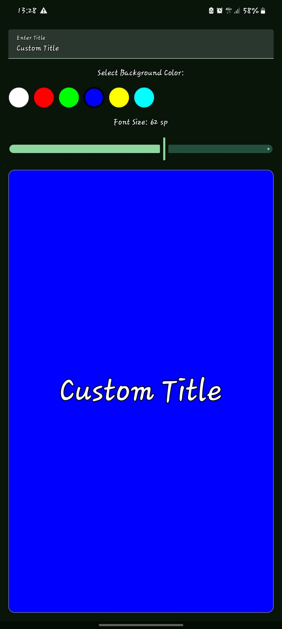
CHANGEABLE TITLE
CHANGEABLE FONT SIZE
CHANGEABLE COLOURS

Tools/software used
- Android studio
- SDK components
- Gemini
Personal reflection
- When the user increases the font size to its maximum limit the title text may clip hence implement text constraints on the preview.
- This project highlights the importance of building decoupled UI elements since the panel at the top behaves independently.
- It shows the importance of intuitive UX by combining multiple inputs types hence minimizes cognitive load for the user.

Week 2: Mobile Development Environment
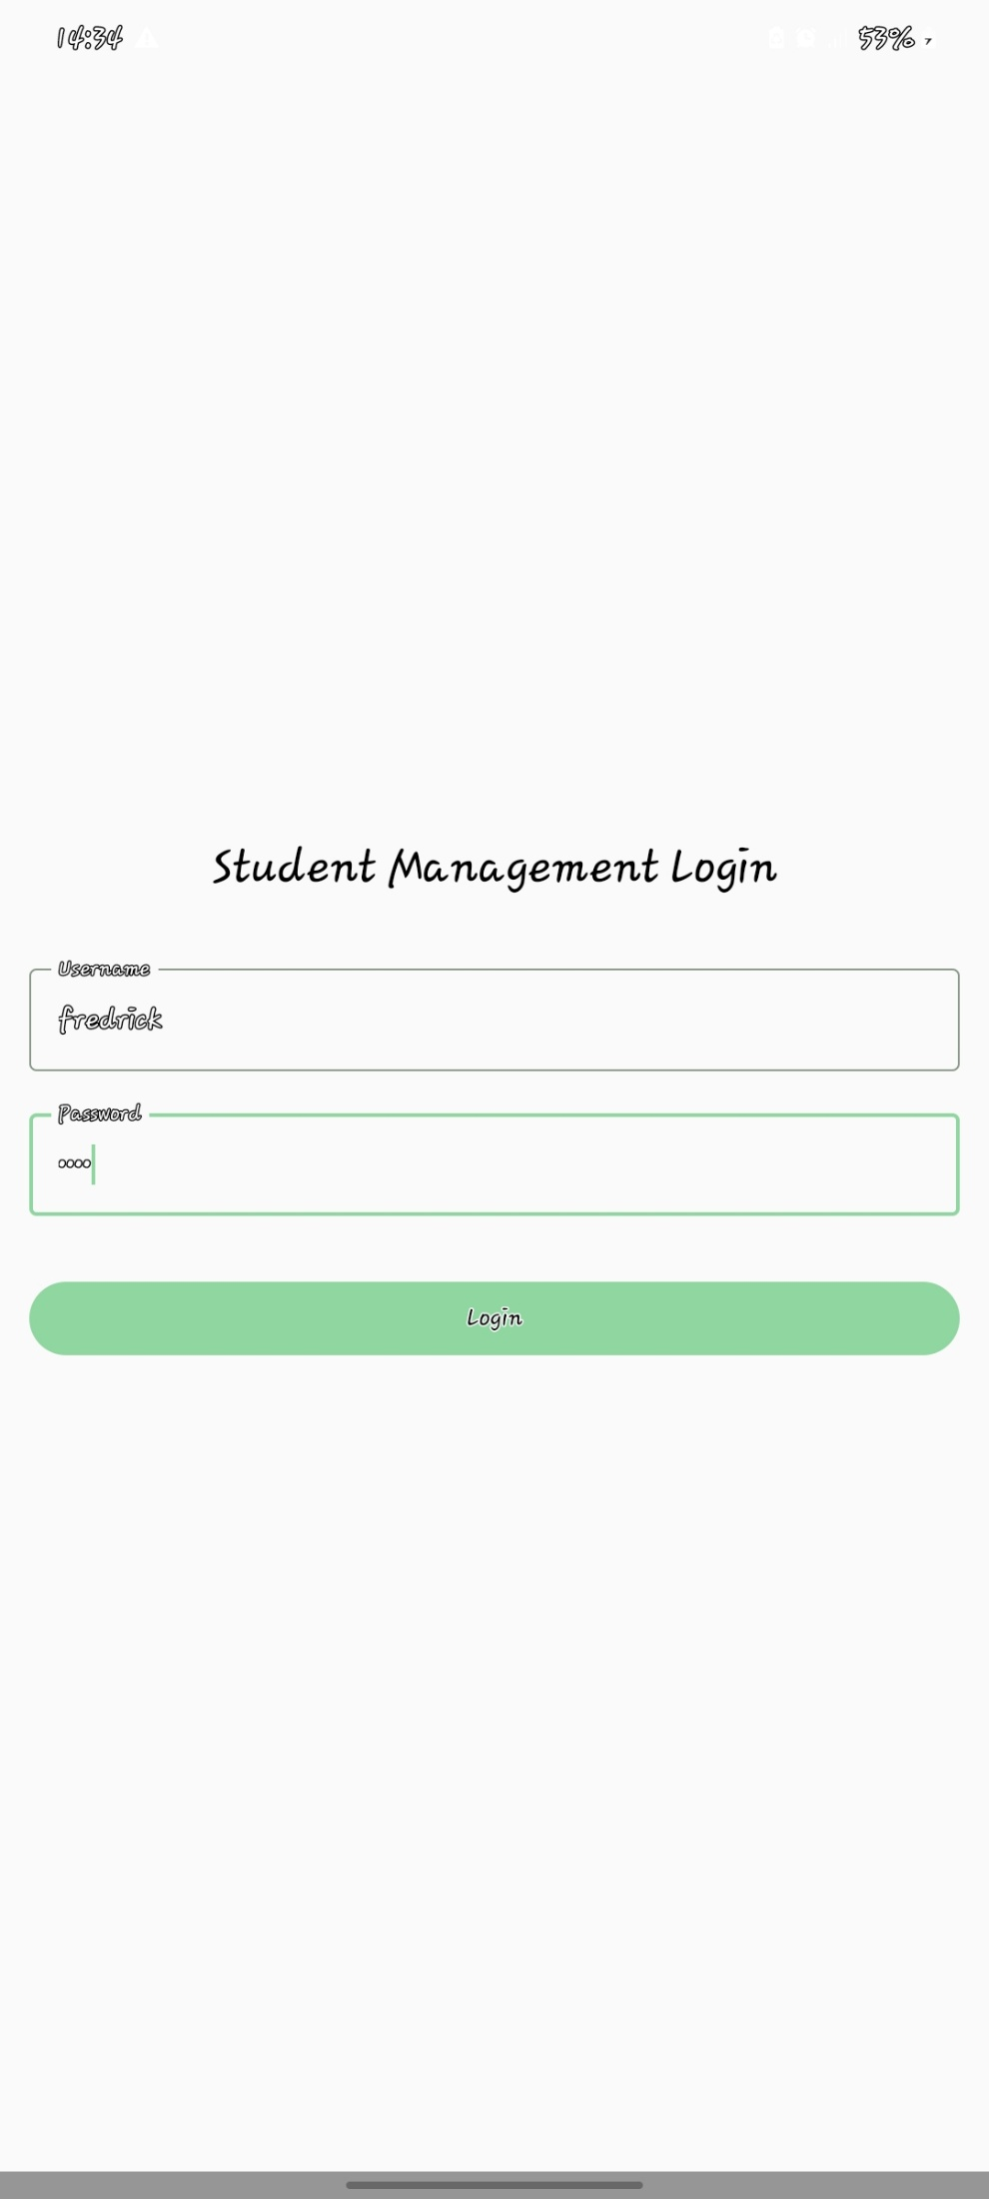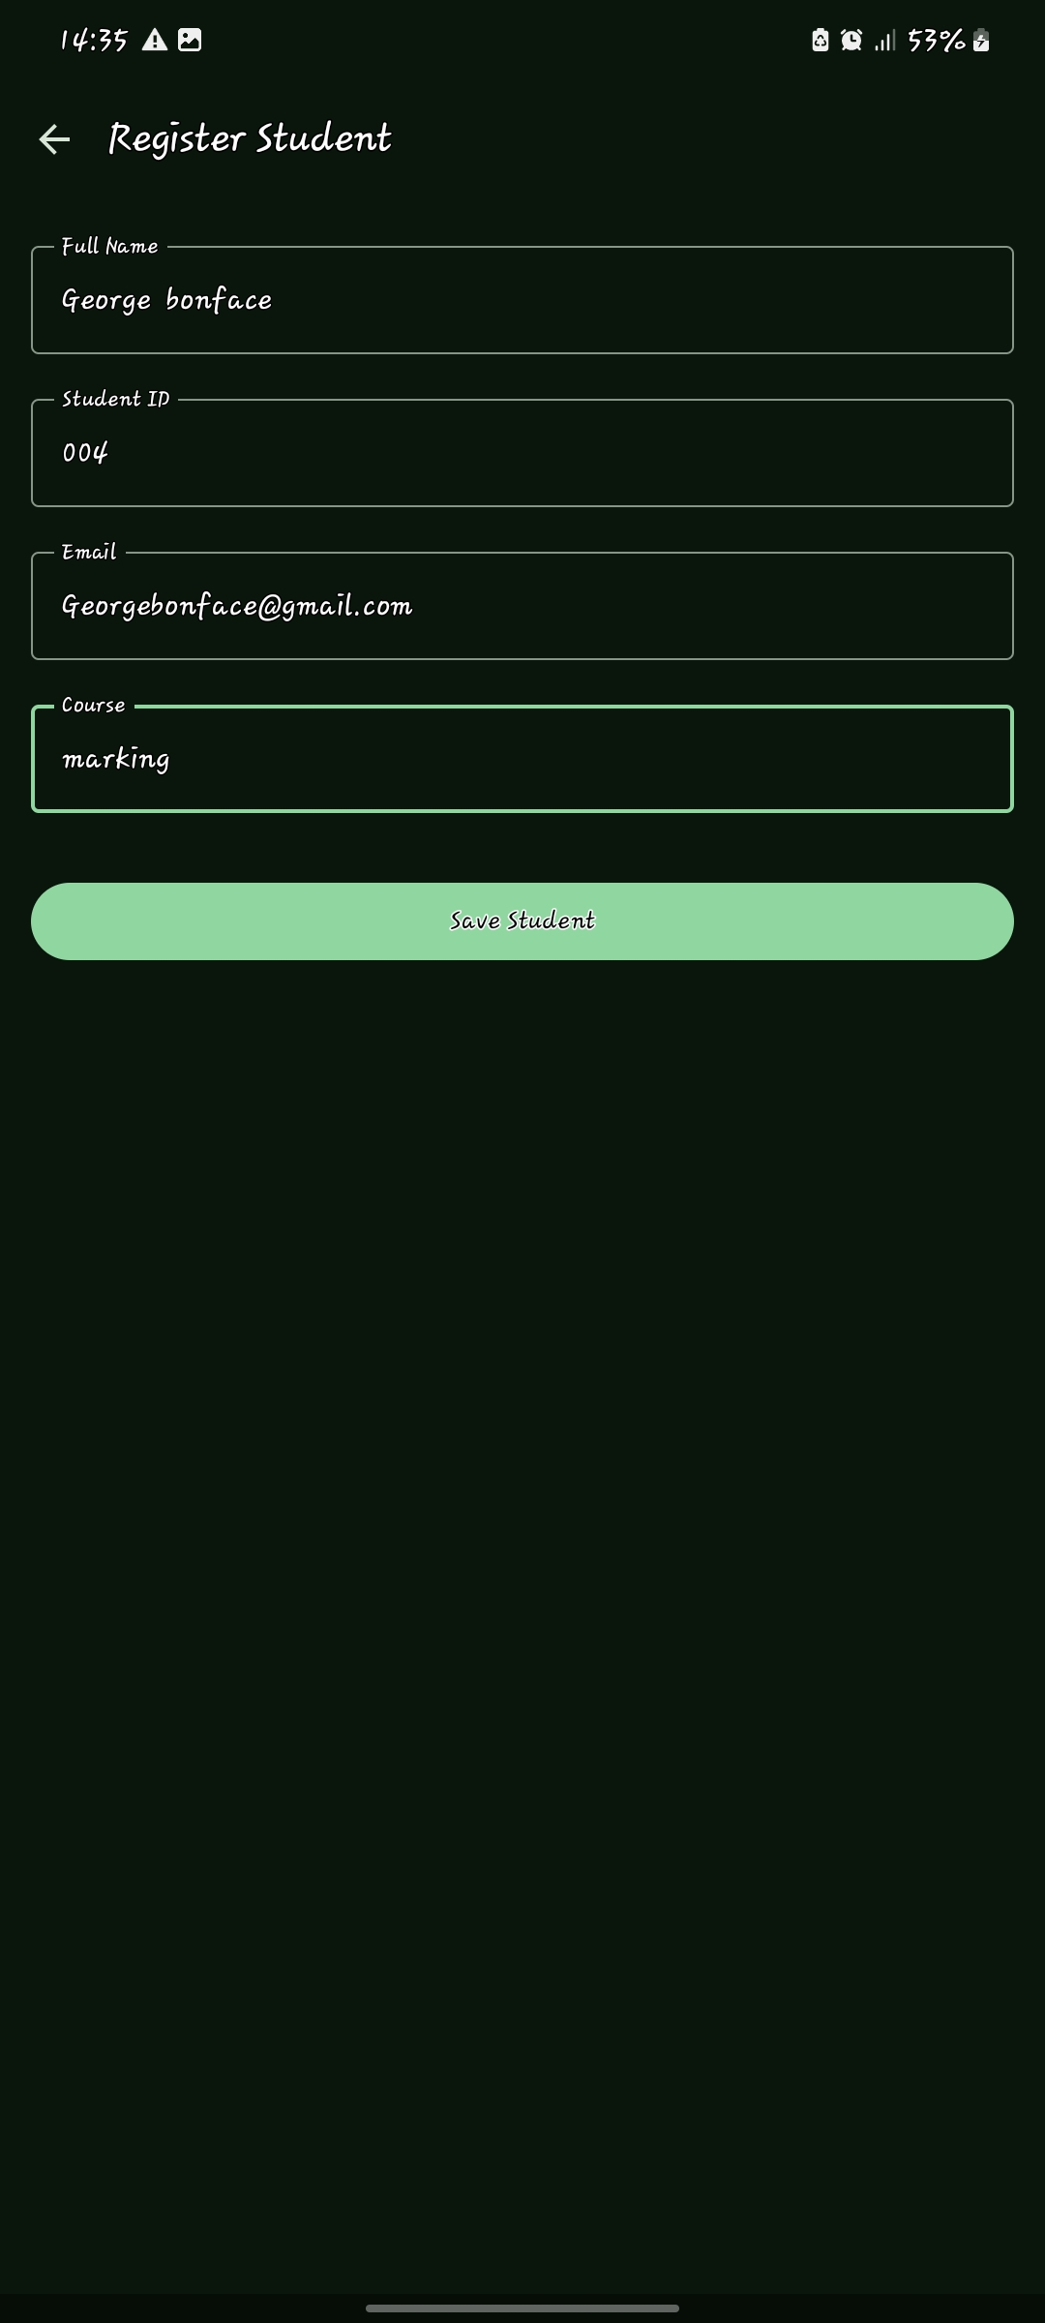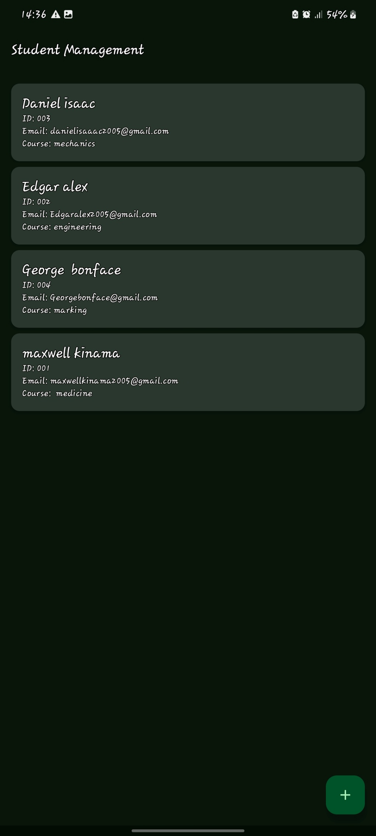
Used to add new student in the record
Press the save student button to save student details on the records
Input login details
Tools/software used
- Android studio
- SDK components
- Gemini
Personal reflection
- The core architecture used in handling user inputs, saving them to storage, reading them in a list and managing security gates serves as the universal foundation for every commercial enterprise.
- Consistency in UI/UX theme since the consistent use of dark backgrounds makes the app feel cohesive, professional and visually intentional

Week 3: User Interface Design
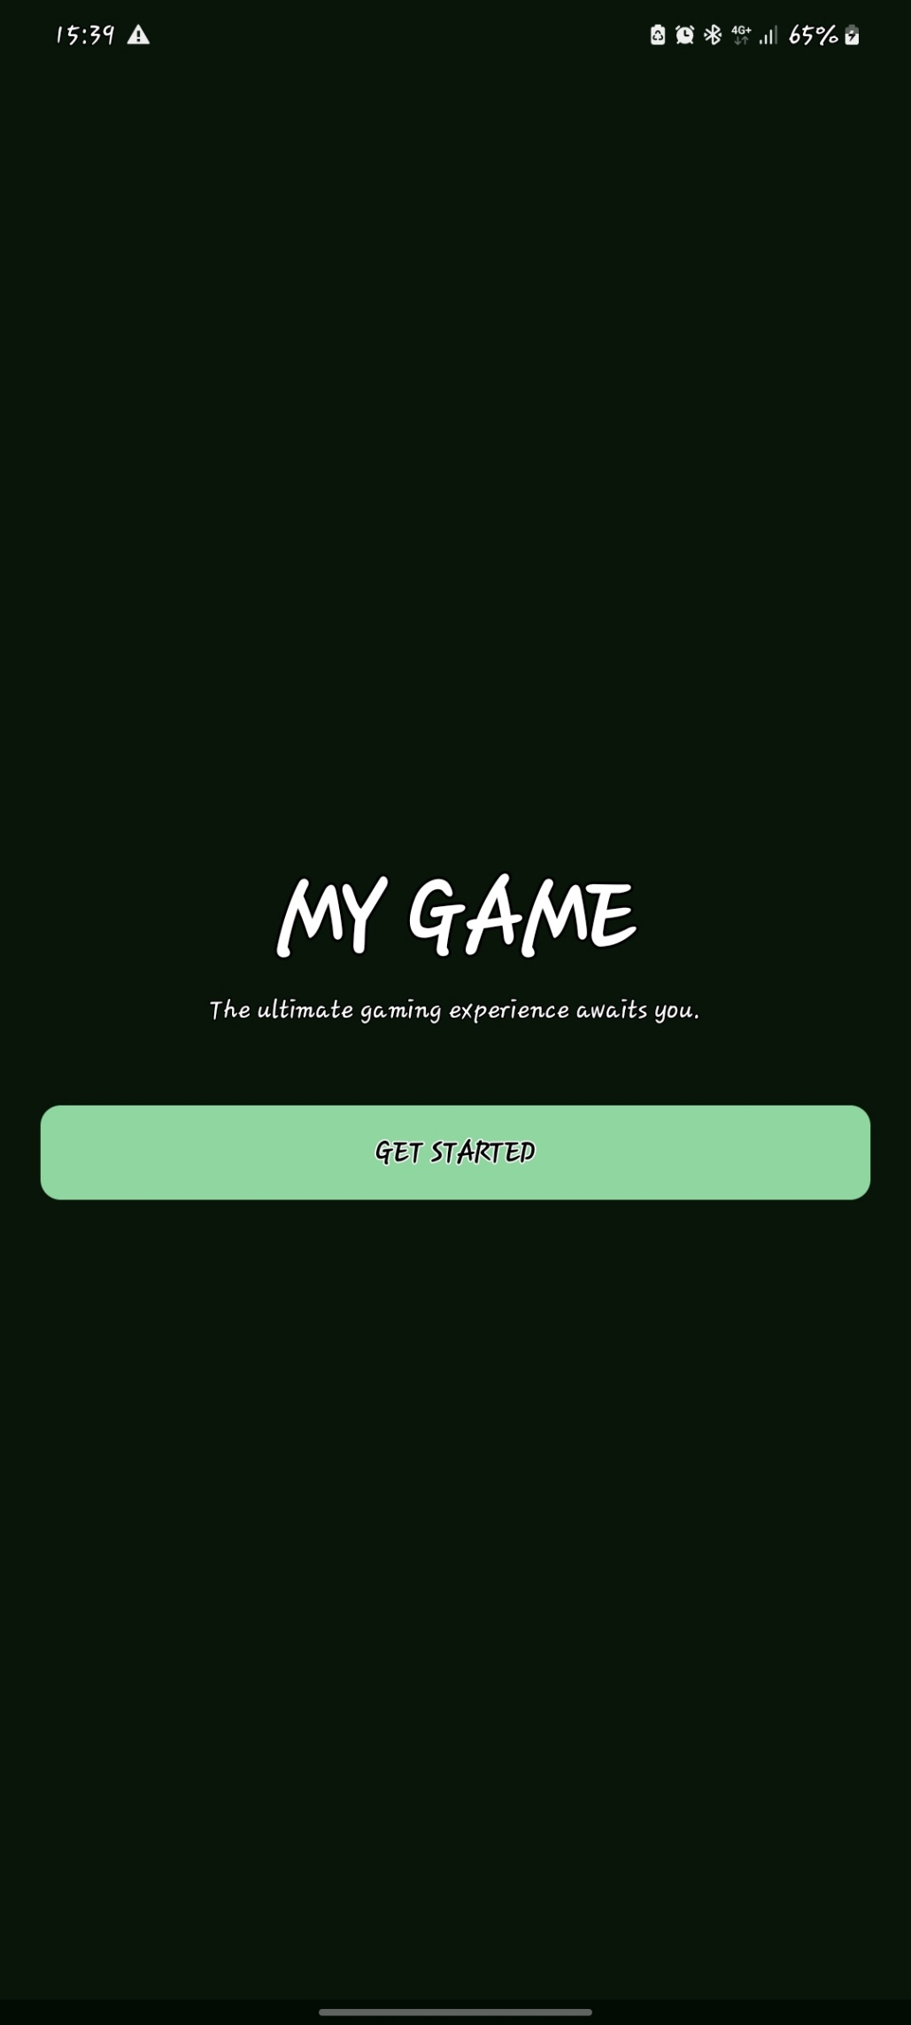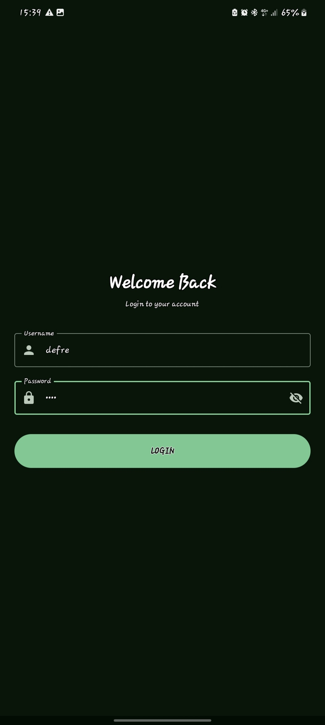
Press here after inputting the login in details to open the app
Press here to start the app
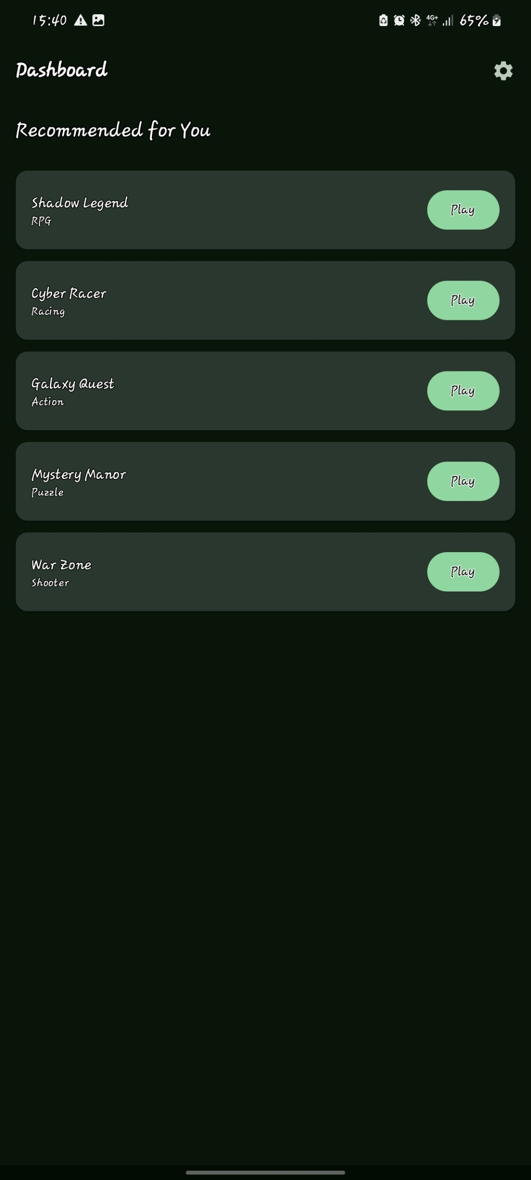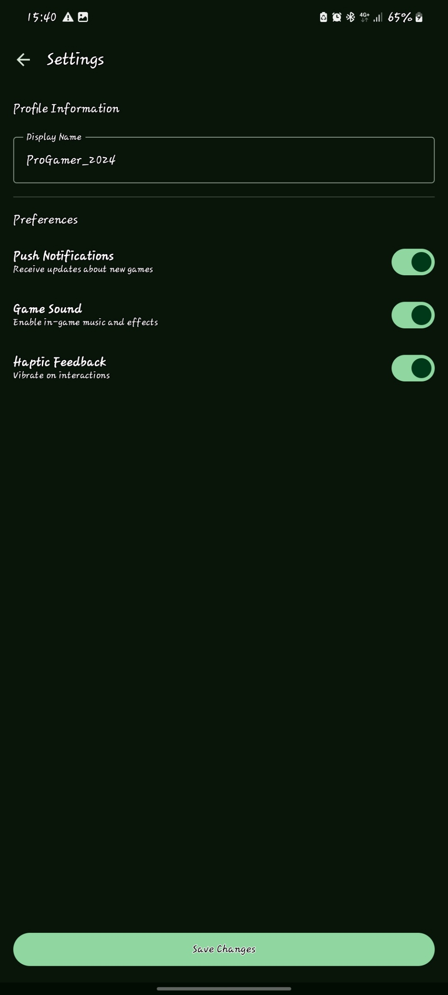
Game settings
This shows the setting of the game
Click here to start your game

Tools/software used
- Android studio
- SDK components
- Gemini
Personal reflection
- In the setting screen when user toggles push notification, game sound or haptic feedback and hits save changes the settings could instantly reset to default the next time the app is launched.
- Populate the dashboard dynamically usings a robust data object structure.

Week 4: Event Handling and User Interaction
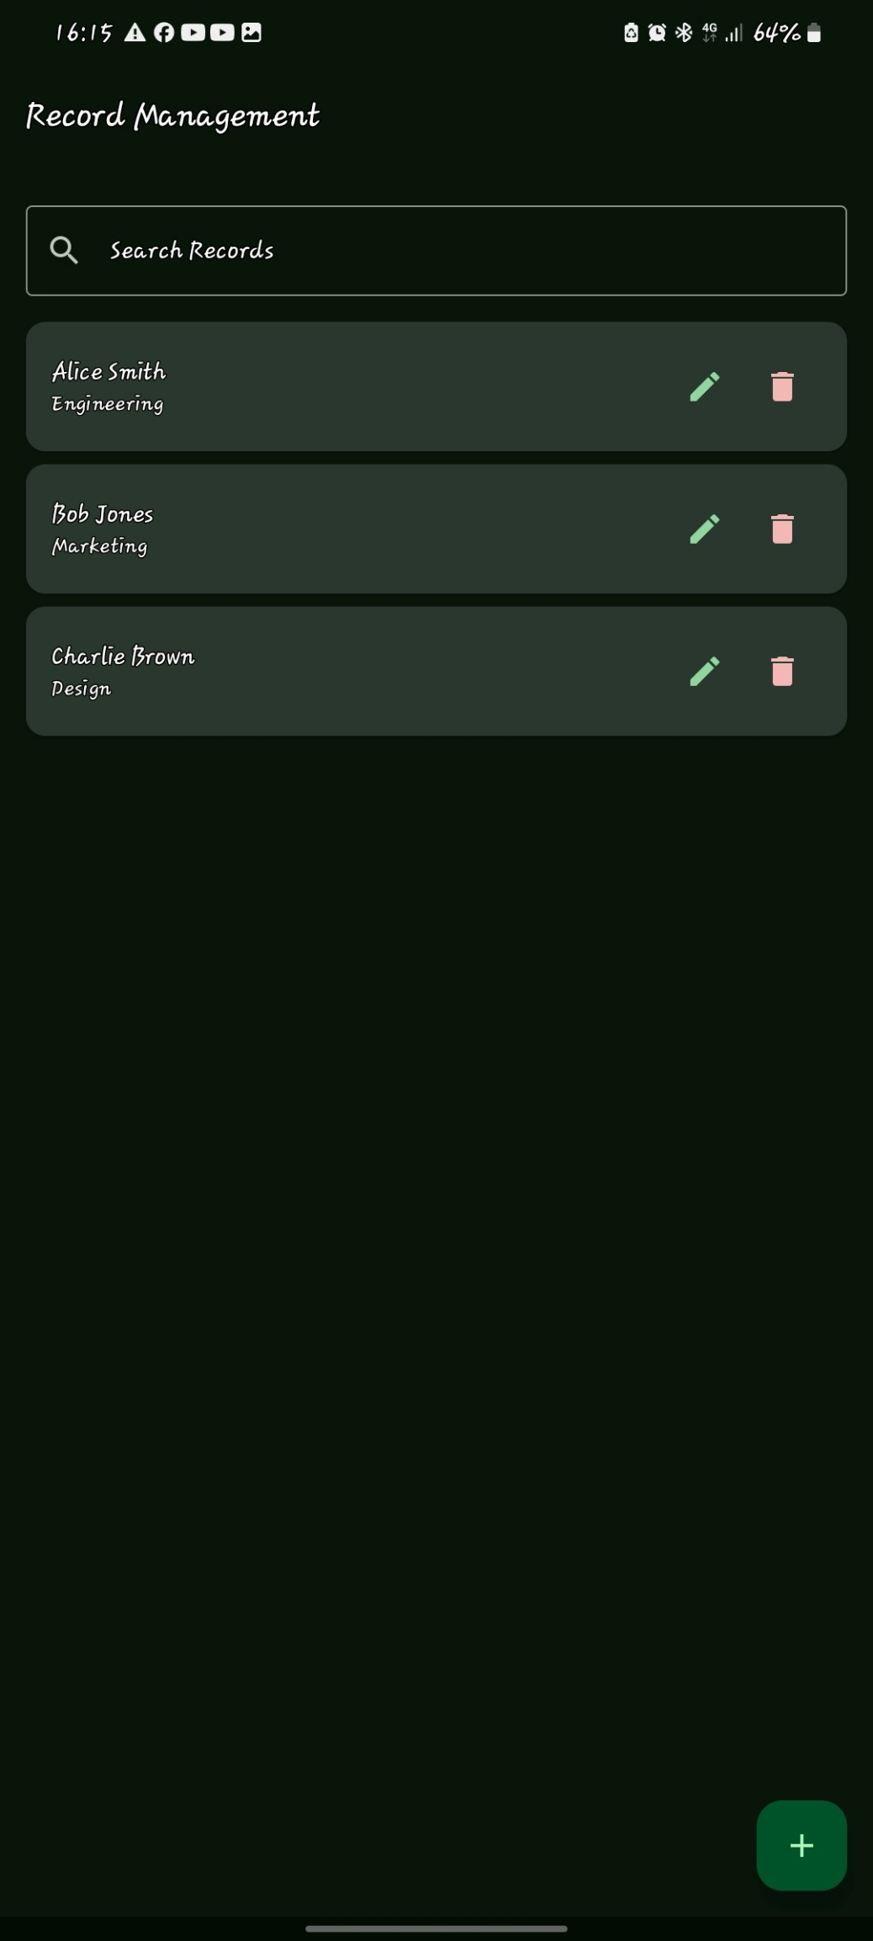
Enables the user to add employee in the record management system
Enables the user to delete an employee from the system
Enables the user to edit employee details
Enables the user to search for an employee in the record management system

Tools/software used
- Android studio
- SDK components
- Gemini
Personal reflection
- Since the trash bin icon sits directly inline inside a scrollable list card, users scrolling down their phone screens can easily mis click the delete icon, immediately wiping out a valid employee record without warning hence it requires carefulness when using the app but implement a synchronous verification gateway when deleting makes it more reliable.

Week 5: Data Management
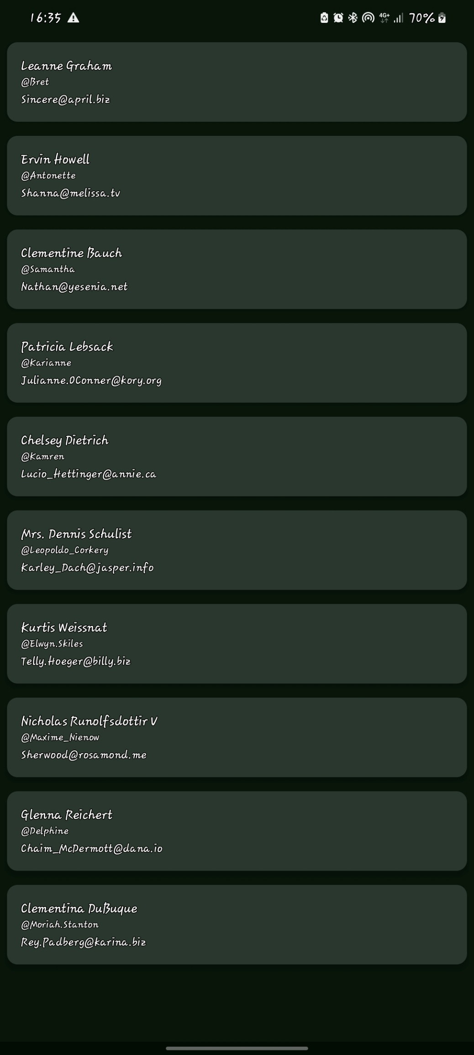

Tools/software used
- Android studio
- SDK components
- Gemini
Personal reflection
This screen marks the transition from local mobile programming to full-stack, connected application development. By successfully mapping live data from a remote server onto your signature dark theme UI components hence bridging the gap between native client layouts and the cloud. The app successfully consumes web APIs and its structural foundation is perfectly primed for complex cloud features.
Week 6: Networking and APIs
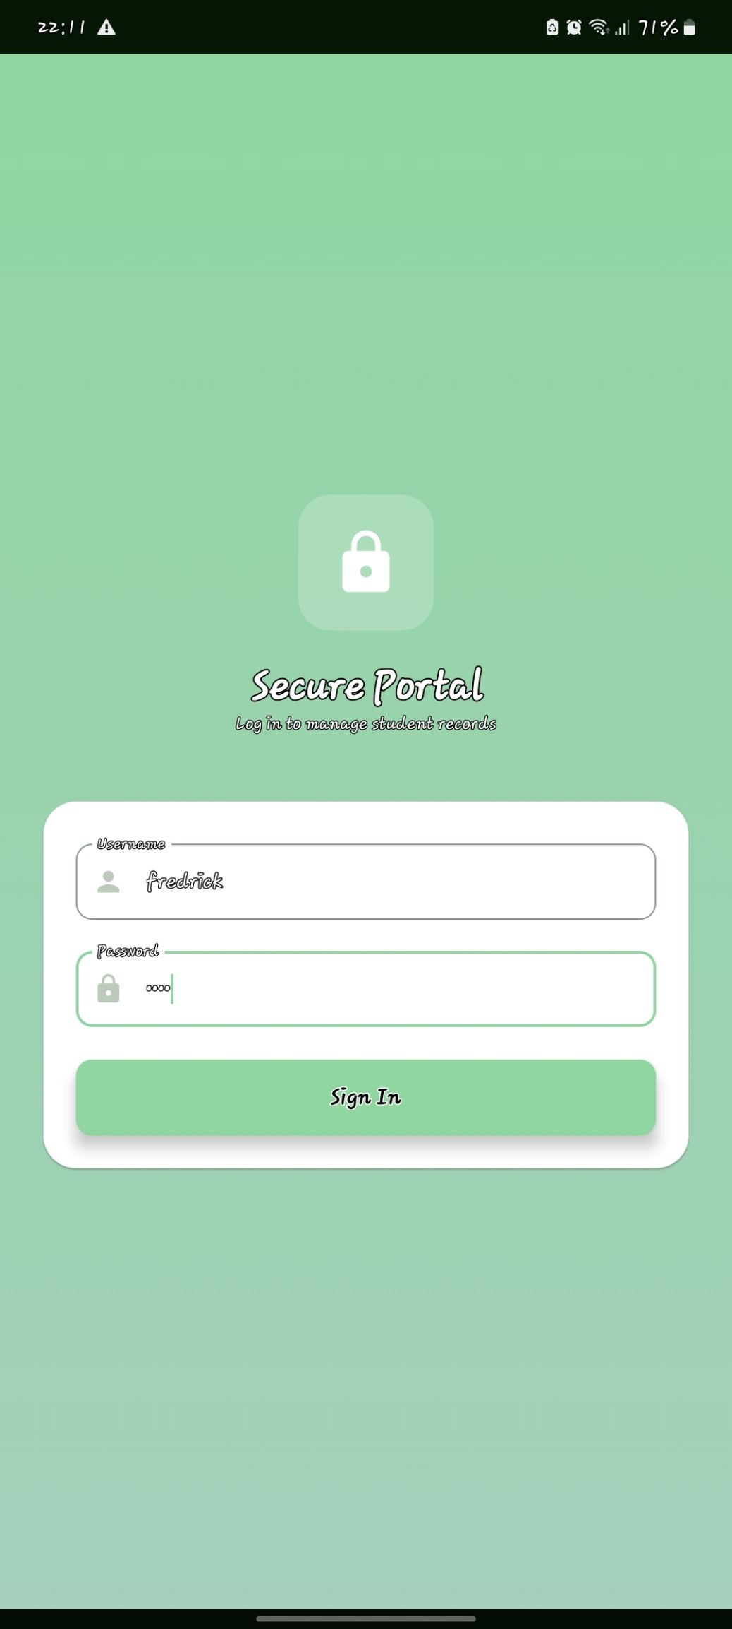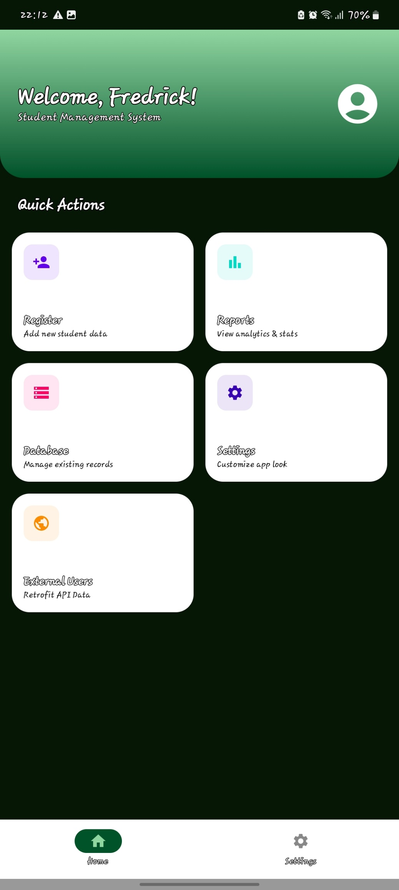
Shows the number of students registered and the external API users
It shows where you can change the title, font sizes and also the background color
It shows the names of the student registered where you can search a creatine student, edit their details, and also delete students from the management system.
It enables registration of new students to the database of management system
Click here after entering the signing details
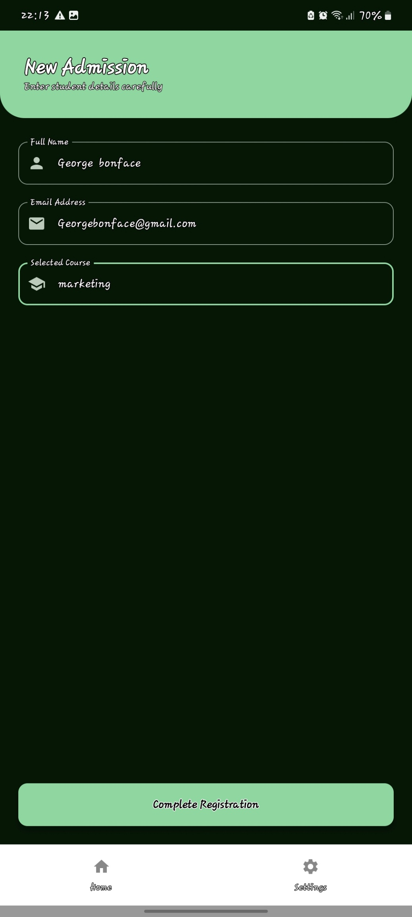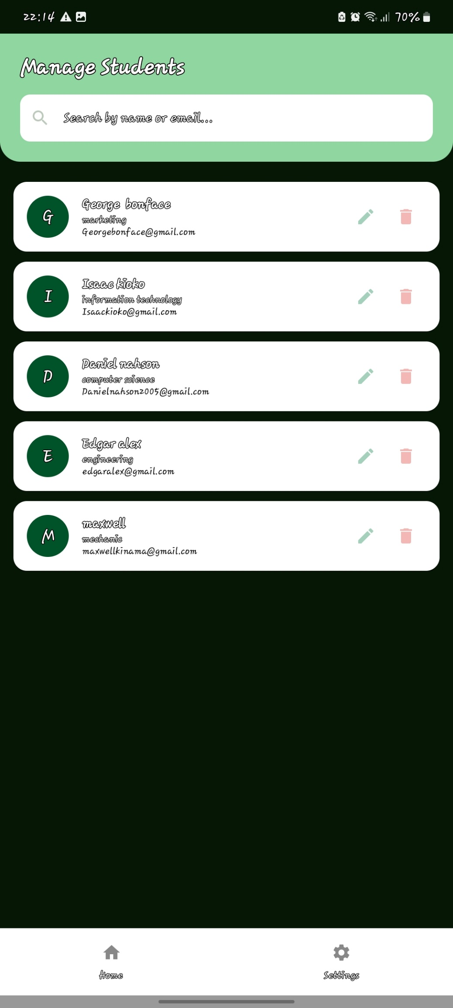
This is the database.it shows the names of the student registered where you can search a certain student, edit their details, and also delete students from the management system.

Click here to complete registration of the new student
This is the register part where you enter the details of the new student
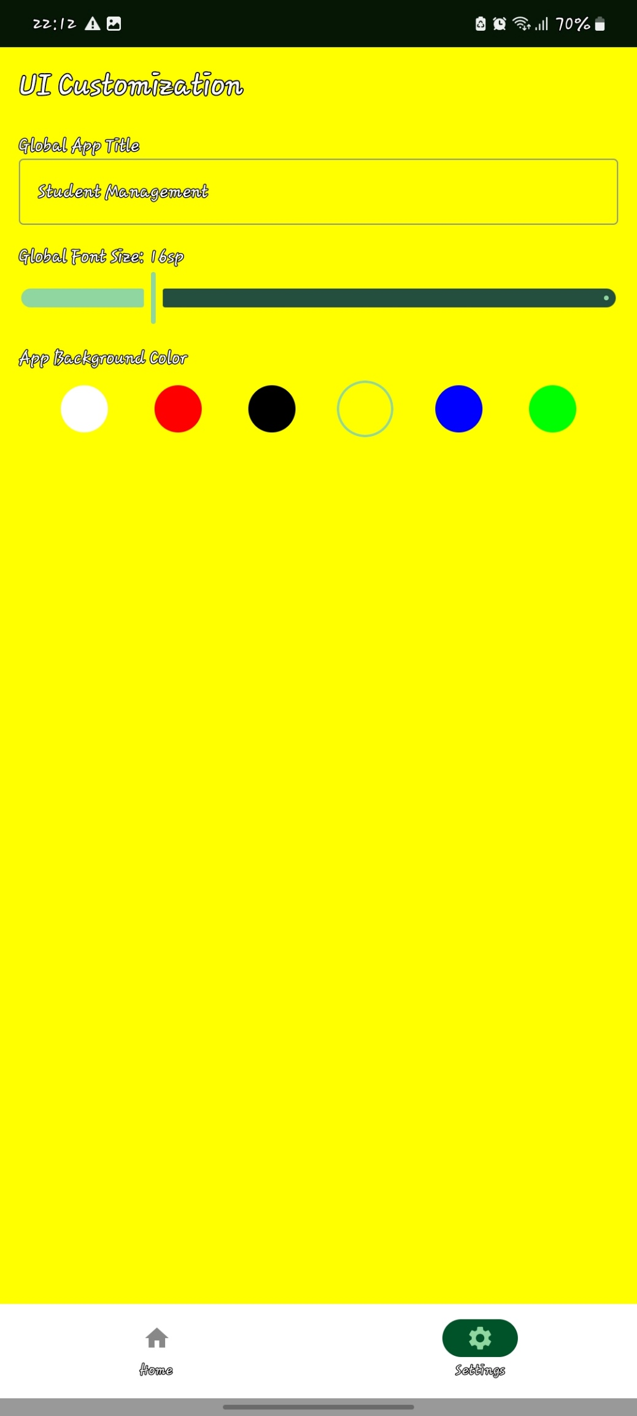
This is the setting part where it changes the appearance of the app like background color, title and font size
These are changeable background colors

Tools/software used
- Android studio
- SDK components
- Gemini
Personal reflection
- Learning how to design a central navigation matrix via grid cards and pairing it with a persistence-friendly bottom navigation bar. This structure allows safe switching between independent app flows (Home vs. Settings) without disrupting current user tasks.
- Transitioning from changing a single component's style to implementing a global user interface settings system. This requires learning how to propagate color values and typography scaling dynamically across the entire application context.

